**National Textile University**

**Department of Computer Science**

Subject: Operating System

Submitted to: Nasir Mahmood

Submitted by: Eemaan Fatima

Reg number:23-NTU-CS-1146

Assignment No.5

Semester:5th

Lab manual 05

**Task 1:**

 #include <stdio.h>

 #include <pthread.h>

 #include <unistd.h>

 // Thread function - this will run in the new thread

 void* thread_function(void* arg) {

 printf("Hello from the new thread!\n");

 printf("Thread ID: %lu\n", pthread_self());

 return NULL;

 }

 int main() {

 pthread_t thread_id;

 printf("Main thread starting...\n");

 printf("Main Thread ID: %lu\n", pthread_self());

 // Create a new thread

 pthread_create(&thread_id, NULL, thread_function, NULL);

// Wait for the thread to finish

 pthread_join(thread_id, NULL);

 printf("Main thread exiting...\n");

 return 0;

 }

Task 2:

 //Passing Arguments to Threads

 // Cgpa of a student and double it

 #include <stdio.h>

 #include <pthread.h>

 void* print_number(void* arg) {

// We know that we've passed an integer pointer

 float num = *(float*)arg; // Cast void* back to int*

 printf("Thread received number: %f\n", num);

 printf("Square of cgpa: %f\n", num * num);

 return NULL;

 }

 int main() {

 pthread_t thread_id;

float cgpa = 3.2;

 printf("Creating thread with argument: %f\n", cgpa);

 // Pass address of 'number' to thread

 pthread_create(&thread_id, NULL, print_number, &cgpa);

 pthread_join(thread_id, NULL);

 printf("Main thread done.\n");

 return 0;

 }

Task 3:

//Passing Arguments to Threads

// Cgpa of a student

#include <stdio.h>

 #include <pthread.h>

 void* print_number(void* arg) {

// We know that we've passed an integer pointer

 float num = *(float*)arg; // Cast void* back to int*

 printf("Thread received number: %f\n", num);

 printf("Double of cgpa: %f\n", num * 2);

 return NULL;

 }

 int main() {

 pthread_t thread_id;

float cgpa = 3.2;

 printf("Creating thread with argument: %f\n", cgpa);

 // Pass address of 'number' to thread

 pthread_create(&thread_id, NULL, print_number, &cgpa);

 pthread_join(thread_id, NULL);

 printf("Main thread done.\n");

 return 0;

 }

Task 4:

//PASING MULTIPLE ARGUMENTS DATA TYPES

//Cgpa of 2 people

#include <stdio.h>

 #include <pthread.h>

 typedef struct {

 float cgpa;

 char* message;

 } ThreadData;

 void* printData(void* arg) {

 ThreadData* data = (ThreadData*)arg;

 printf("cgps %f is %s\n", data->cgpa, data->message);

 return NULL;

 }

 int main() {

 pthread_t t1, t2;

 ThreadData data1 = {3.2, "My name is Eman"};

 ThreadData data2 = {3, "My name is Nimra"};

 pthread_create(&t1, NULL, printData, &data1);

 pthread_create(&t2, NULL, printData, &data2);

 pthread_join(t1, NULL);

 pthread_join(t2, NULL);

 printf("All threads done.\n");

 return 0;

 }

Task 5:

 #include <stdio.h>

 #include <pthread.h>

 #include <stdlib.h>

 void* calculate_sum(void* arg) {

 int n = *(int*)arg;

 int* result = malloc(sizeof(int)); // Allocate memory for result

 *result = 0;

 for (int i = 1; i <= n; i++) {

 *result += i;

 }

 printf("Thread calculated sum of 1 to %d = %d\n", n, *result);

 return (void*)result; // Return the result

 }

 int main() {

 pthread_t thread_id;

 int n = 100;

 void* sum;

 pthread_create(&thread_id, NULL, calculate_sum, &n);

 // Get the return value from thread

 pthread_join(thread_id, &sum);

 printf("Main received result: %d\n", *(int*)sum);

 free(sum); // Don't forget to free allocated memory

 return 0;

 }

Task 6:

#include <stdio.h>

#include <pthread.h>

typedef struct

{

    int id;

    char *message;

} ThreadData;

void *printData(void *arg)

{

    ThreadData *data = (ThreadData *)arg;

    printf("Thread %d says: %s\n", data->id, data->message);

    return NULL;

}

int main()

{

    pthread_t t1, t2;

    ThreadData data1 = {1, "Hello"};

    ThreadData data2 = {2, "World"};

    pthread_create(&t1, NULL, printData, &data1);

    pthread_create(&t2, NULL, printData, &data2);

    pthread_join(t1, NULL);

    pthread_join(t2, NULL);

    printf("All threads done.\n");

    return 0;

}

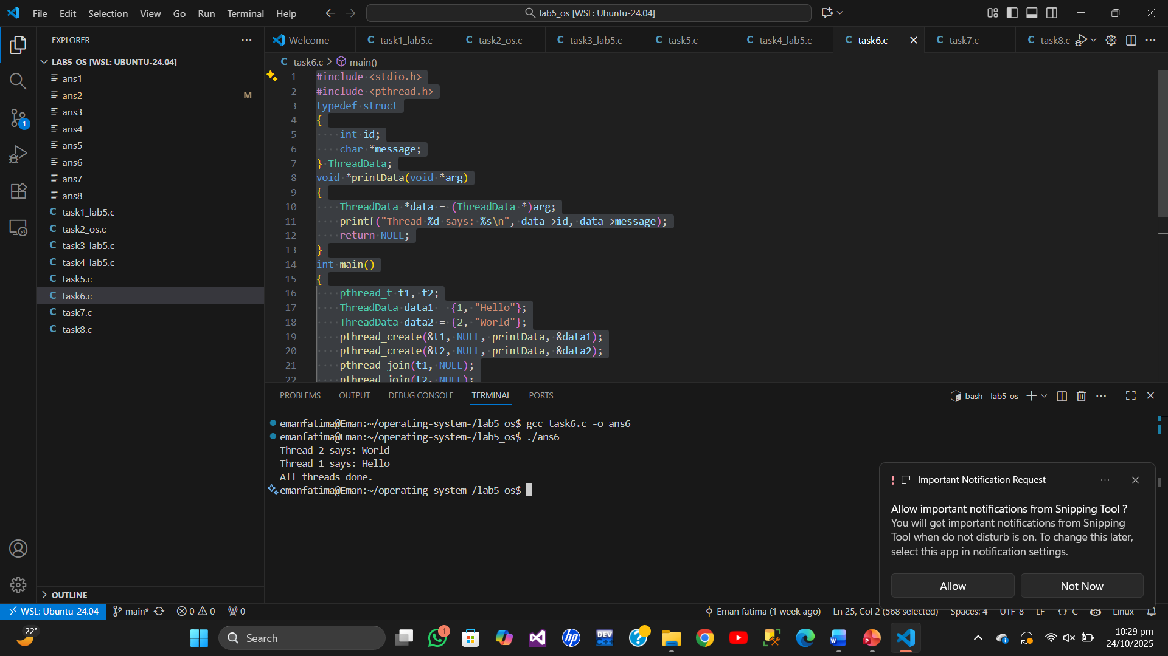

Task 7:

#include <stdio.h>

#include <pthread.h>

#include <unistd.h>

void *worker(void *arg)

{

    int thread_num = *(int *)arg;

    printf("Thread %d: Starting task...\n", thread_num);

    sleep(1); // Simulate some work

    printf("Thread %d: Task completed!\n", thread_num);

    return NULL;

}

int main()

{

    pthread_t threads[3];

    int thread_ids[3];

    for (int i = 0; i < 3; i++)

    {

        thread_ids[i] = i + 1;

        pthread_create(&threads[i], NULL, worker, &thread_ids[i]);

    }

    for (int i = 0; i < 3; i++)

    {

        pthread_join(threads[i], NULL);

    }

    printf("Main thread: All threads have finished.\n");

    return 0;

}

Task 8:

#include <stdio.h>

#include <pthread.h>

int counter = 0; // Shared variable

void *increment(void *arg)

{

    for (int i = 0; i < 100000; i++)

    {

        counter++; // Not thread-safe

    }

    return NULL;

}

int main()

{

    pthread_t t1, t2;

    pthread_create(&t1, NULL, increment, NULL);

    pthread_create(&t2, NULL, increment, NULL);

    pthread_join(t1, NULL);

    pthread_join(t2, NULL);

    printf("Expected counter value: 200000\n");

    printf("Actual counter value:   %d\n", counter);

    return 0;

}

